National University of Computer and Emerging Sciences, Lahore Campus
 | Course: | Operating Systems | Course Code: | CS2006
 | Program: | BDS | Semester:
 | Section: | 6A | Total Marks: | 10
 | Submission deadline: | 01-03-2023 | Weight | 3.3
 | Assignment:1 |  | Page(s): | 2
Instruction/Notes: | - Understanding of the problems is part of the assignments. So, no query please.  - You will get Zero marks if found any type of cheating.  - 25 % deduction of over marks on the one-day late submission after due date  - 50 % deduction of over marks on the two-day late submission after due date  - No submission after two days.  - MUST BE HANDWRITTEN.
Question: 1-State all the two newly added States and their respective transitions in 7-state process model shown below in figure, also mention which scheduler will be responsible for doing the state change from one to other. As per our class discussion, medium term scheduler is responsible for SWAP IN and SWAP OUT (Swapping), After SWAP OUT which process will get the higher priority to SWAP IN back to the Ready queue or blocked queue and why? Justify your answer.
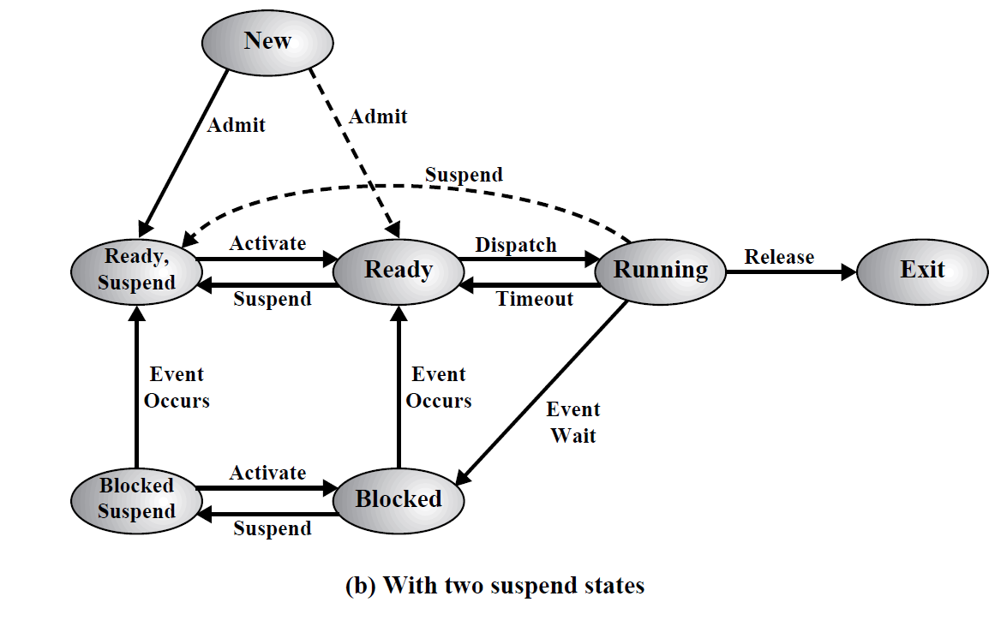
Question:2- Consider the following C program which is executed on a Unix/Linux system, what will be the output of the following code? Justify your answer by making tree structure.
int main()
{
if (fork () || fork ())
{
fork ();
}
printf("OS");
return 0;
}

- How many times String “OS” will be printed? And why?
- How many total number of child processes will be created by the above program? Justify your answers by making Process tree.

Question:3- Consider the following set of processes, with the length of the CPU-burst time given in milliseconds:
Process ID Arrival Time Burst Time Priority
P₁ 2 6 2
P₂ 5 12 3
P₃ 1 18 4
P₄ 0 13 5
P₅ 4 3 2

- Draw four Gantt charts illustrating the execution of these processes using SJF (Preemptive)/SRTF, Priority (Preemptive) the lowest the priority number the highest the priority, and Round Robin (Preemptive w.r.t Burst time) (quantum = 5) scheduling.
- What is the turnaround time of each process for each of the scheduling algorithms in part (a)?
- What is the waiting time of each process for each of the scheduling algorithms in part (a)?
- Which of the scheduling algorithm in part (a) results in the minimal average waiting time (over all processes)?

